Jennifer Stegina

13 September 2019

CIS 250

**Unit 3 Guided Practice 4**

The following questions come from the Task examples of Chapters 11 & 12 in your textbook.

After you are finished, please submit a Microsoft Word file that contains screenshots of the SQL Queries, the output, and put a comment line in the query with your last name. Your document should be named **U3_GuidedPractice4_Lastname.docx**.

(11-3) Question 1:

Find the following:

■ The minimum credit limit given to any employee

■ The maximum credit limit given to any employee

■ The first name of an employee that comes last alphabetically

■ The last name of an employee that comes last alphabetically

■ The latest date when any of the employees was hired

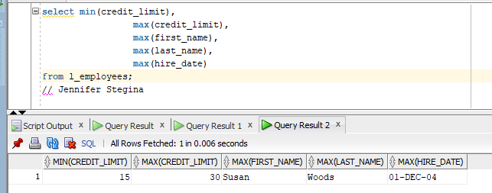

(11-5) Question 2:

Find all the employees who have the minimum credit limit.



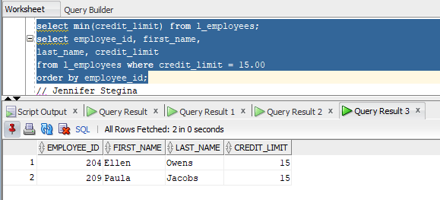

(11-7) Question 3:

In Oracle, apply all the column functions to the column that contains only nulls. Show that the *count(column)* function results in a zero, but the *max, min, sum*, and avg functions result in a null.

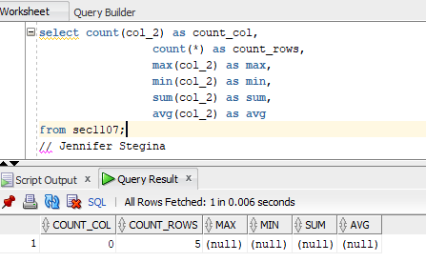

(11-9) Question 4:

Count the number of distinct combinations of *manager_id* and *credit_limit*.

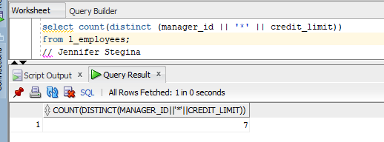

(11-12) Question 5:

Find the total for all the invoices in the table. Calculate an invoice as:

(Price * Quantity) + Tax + Shipping = Invoice

Estimate values for the nulls that occur in the *tax* and *shipping* columns by applying these rules:

1. Replace a null in the *tax* column with:

*0.07 * price * quantity*

2. Replace a null in the *shipping* column with:

*0.12* price * quantity*

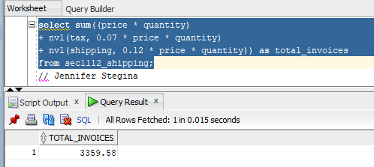

(11-14) Question 6:

Count the number of different dates in the *date_entered* column of the *l_lunches* table.

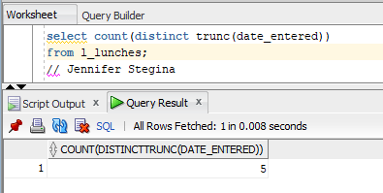

(12-2) Question 7:

For each *manager_id*, list the number of employees each one manages. Also list the range of their employees’ credit limits by showing the minimum and maximum. Omit employee 202.

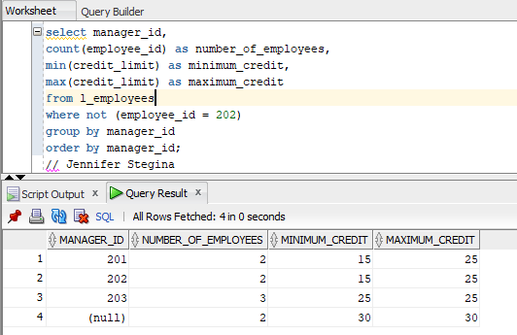

(12-5) Question 8:

Show the error that occurs when a summarized column and a nonsummarized column both occur within the same select statement.

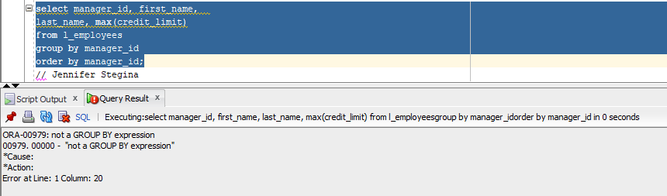

(12-9) Question 9:

From the *l_lunches* table, count the number of lunches each employee will attend.

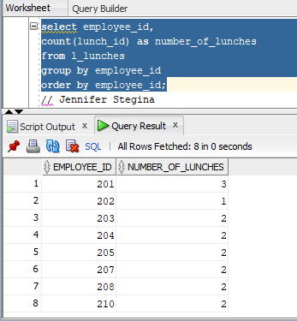

(12-10) Question 10:

Count the number of lunches each employee will attend. List the employee IDs and names of all the employees.

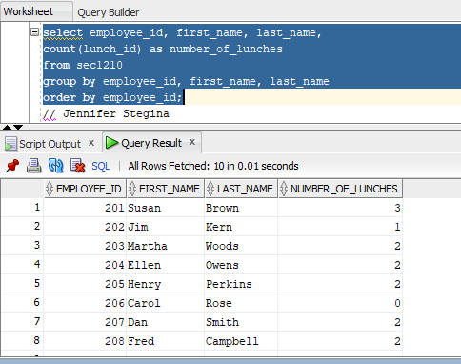

(12-15) Question 11:

For each *manager_id* between 201 and 203, show the number of employees the manager supervises.

